1. Many developers consider that lambda expression is very much similar to inner anonymous class but that is not true.
2. Let’s understand the relationship b/w the lambda expression and inner anonymous class.
3. 
4. 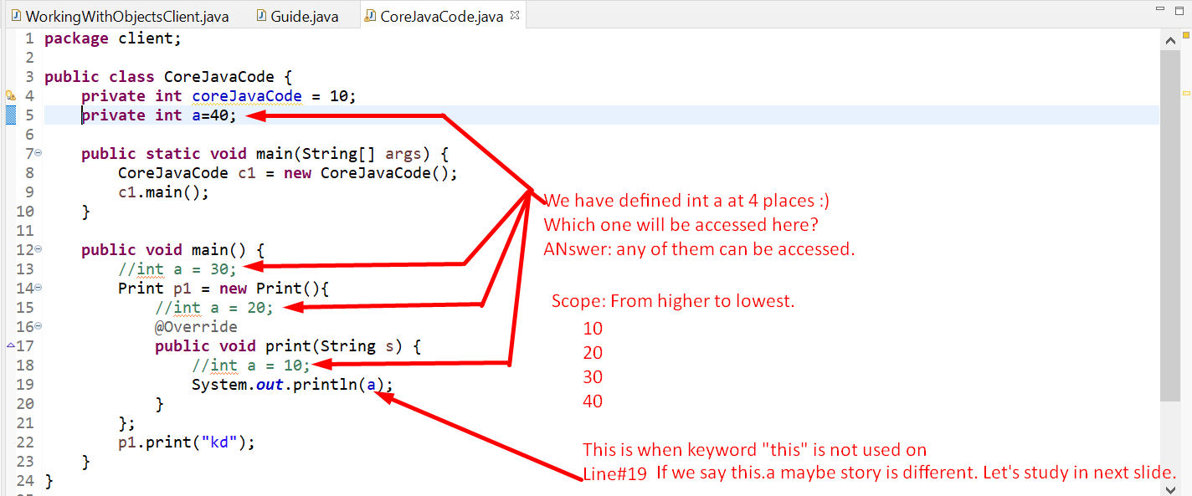
5. 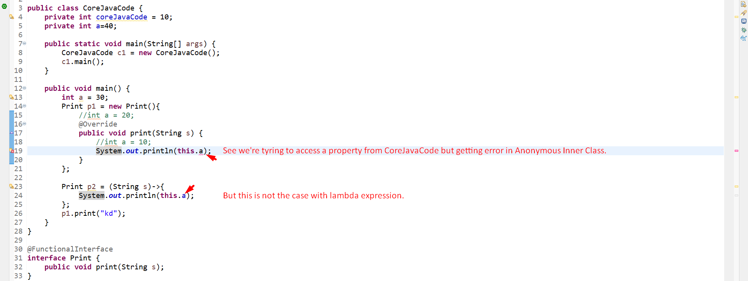
6. 